Imagine a book that is reviewed in both The Lancet and High Times.

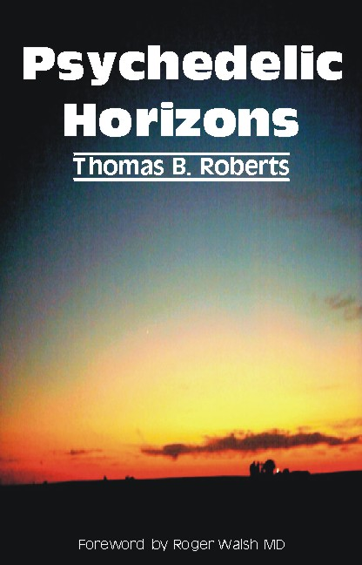
Thomas B. Roberts
Ph.D.

foreword by
Roger N. Walsh
MD

How do you request a copy to consider for a review?

sandra@imprint.co.uk

The Lancet review of Psychedelic Horizons

The Lancet
Vol. 369, January 13, 2007

Book An affirming trip by Kelly Morris

Reading Psychedelic Horizons, for me, was itself like some descriptions of a “trip”, or psychedelic experience. The initial effect, for the first few chapters, is puzzling, a state where I felt something deeper existed within the fragments being laid out—images from childhood, views of psychology, art, eastern religion, and psychedelia, naturally. Then, and I cannot quite put my finger on the exact point, there is an “a ha!” moment where the pieces click into place, and the horizons become clear. From then on, the book unfolds aspect after aspect of original thought, leading to a brighter future view—an affirming trip. Thomas Roberts has taught a course on psychedelics for decades, and this book is a suitable accompaniment. But, more fundamentally, he challenges swathes of current thinking by asking questions about altered states of consciousness, including those induced by psychedelics. The variety of these experiences clearly suggests our minds are multistate, and prompt further questions about the potential of these different states for healing, psychology, cognitive studies, and education. The only “come down” is when he poses bioethical questions of the future, related to what he calls “mindbody psychotechnologies”. I am left wondering whether we will solve such future dilemmas as insightfully as Roberts has explored them.
High Times review of Psychedelic Horizons
by Preston Peet
Originally published in High Times Magazine,
October 2006
Is it possible that extremely powerful, positive psychedelic drug experiences can boost our immune systems and strengthen our health? Can taking psychedelic drugs help increase human intelligence and creativity? Is the insistence by most modern science and those waging their War on Some Drugs that ideas and perceptions formed under the influences of psychedelics and other altered states of consciousness are false and hallucinatory only wrong, and has the reliance on only ideas and perceptions formed during so-called normal states of mind limited our learning about psychology, health, and the vast potential of human thought?
In "Psychedelic Horizons," (Imprint Academic [UK] Philosophy Documentation Center, VA) Thomas B. Roberts, a Professor in the Department of Leadership, Educational Psychology and Foundations at Northern Illinois University for 30 years, says that indeed, this "Single State Fallacy," the "erroneous assumption that all worthwhile abilities reside in our normal, awake mindbody state," indeed "stunts ourselves, our children, and the human future by teaching only one mental state-one cognitive program."
Roberts' ideas are described in a refreshing and remarkably personal way. Broken into four distinct sections, "Psychedelic Horizons" is a fascinating examination of the possibilities for human mind and psychedelic potential and perspective, increased health and a stronger immune system. This is a guide to "thinking about thinking" and how to gain a much wider view of what constitutes reality around and within us. While not entirely original, Roberts' thesis is basically, "that there are more to our minds than our normal awake state," and that while there are other ways to reach this realization, such as "meditation, dreams, anesthetics, stimulants," psychedelics are "so powerful and so overwhelming that one simply cannot ignore them." Using such substances may make it possible to not only enlarge our learning capacity but even become more intelligent, "well educated" beings.

Author Bio

Thomas B. Roberts (A.B. Hamilton College, M.A. University of Connecticut, Ph.D. Stanford) is a Professor Emeritus at Northern Illinois University, where he has taught Foundations of Psychedelic Studies since 1982 (currently as an Honors Program Seminar). It is the first catalog-established, university psychedelics course.

In 1995, he organized an entheogen conference co-sponsored by the Chicago Theological Seminary and the Council on Spiritual Practices resulting in Psychoactive Sacramentals (2001). His major publications include Psychedelic Horizons: Snow White, Immune System, Multistate Mind, Enlarging Learning (2006), and the 2-book set Psychedelic Medicine: New Evidence for Hallucinogenic Substances as Treatments (forthcoming 2007). He compiled the online archive Religion and Psychoactive Sacraments (1992-2001) www.csp.org/chrestomathy. The latter contains expanded bibliographic information and selected excerpts from over 550 books, topical issues of journals, and dissertations having to do with the entheogenic uses of psychoactive plants and chemicals. He contributed the entheogen chapter to the 3-volume set Where God and Science Meet (McNamara, 2006) and at the request of a publisher, is expanding it into a book Increasing Spiritual Intelligence - - Chemical Input, Religious Output.

He is a founding member of the Multidisciplinary Association for Psychedelic Studies and of the International Transpersonal Association and a co-founder of the Council on Spiritual Practices. As the first of his retirement activities, he spent the fall of 2006 as a Visiting Scientist at the Johns Hopkins Medical School’s Behavioral Biology Research Center, where he chaired a weekly staff development seminar about psychedelics with the Griffiths psilocybin research team. He originated Bicycle Day.

Table of Contents

Foreword by Roger Walsh, MD ix
Chapter 1 Beyond Tripping — Psychedelic Horizons 1

Part 1 — Snow White: Grofian Psychocriticism
Chapter 2 Sometimes It’s Lucky to be a Professor 17

Chapter 3 Snow White: Grof’s Landmarks in Disney’s Land 29
Chapter 4 A Thinking Project 45

Part 2 — The Emxis Speculation
Chapter 5 Binker’s Bicycle Day Stoned Idea 54
Chapter 6 Do Entheogen-induced Mystical Experiences Boost
the Immune System? Psychedelics, Peak Experiences,
and Wellness 61
Chapter 7 From POTT MUSIC to Spontaneous Remission 78

Part 3 — Multistate Mind
Chapter 8 Bigger, Stronger, Brighter — A New Relationship
with our Minds 101
Chapter 9 The Multistate Paradigm 113
Chapter 10 Intelligence, Creativity, Metaintelligence 120
Chapter11 Psychology, Science, and Survival 133
Chapter 12 The Major Intellectual Opportunity of Our Times —
The Central Multistate Question 150

Part 4 — Multistate Education
Chapter 13 It Means Something Different to be Well Educated 163
Chapter 14 Enlarging Learning
Chapter 15 Is the Reprogrammable Brain Adaptigenic? 173
Chapter Notes 210
References 228
Index 238

